Guide For Using Phone number (Webrtc)
Note -Intimate subbaraju if your requirement(Omsai LLC business needs) needs a new phone number
- Brief Foreword
The phone integration is based on webrtc technology and is integrated with Omsai Teams. Omsai com LLC is customer related organization and communication with clients and its management is very important factor in growing its potential.
The present integration provides calls management for making, receiving, missed calls and necessary follow up.

- Calls Management
All calls made and received information is recorded for proper and necessary follow up management.
Example – If a call received say for tax number, it shall ring for all the people allotted to Omsai com LLC phone number (It shall ring which is set as active number). If nobody lifts it shall be recorded as missed call and needs to follow up to close it.
Note – You can use SMS integration to send SMS if unavoidable situation. (SMS is not a proper communication method and avoid its usage to avoid for the phone number to be designated as spam)
- Snap shots of the interface

Important points to remember–
- Anybody calls or receiving calls (To add the phones numbers in Contacts)
- Missed Calls/SMS received to be followed up
- Should maintain numbers as per Omsai Business needs (say call a tax client by Omsai com LLC tax number only and so on…)

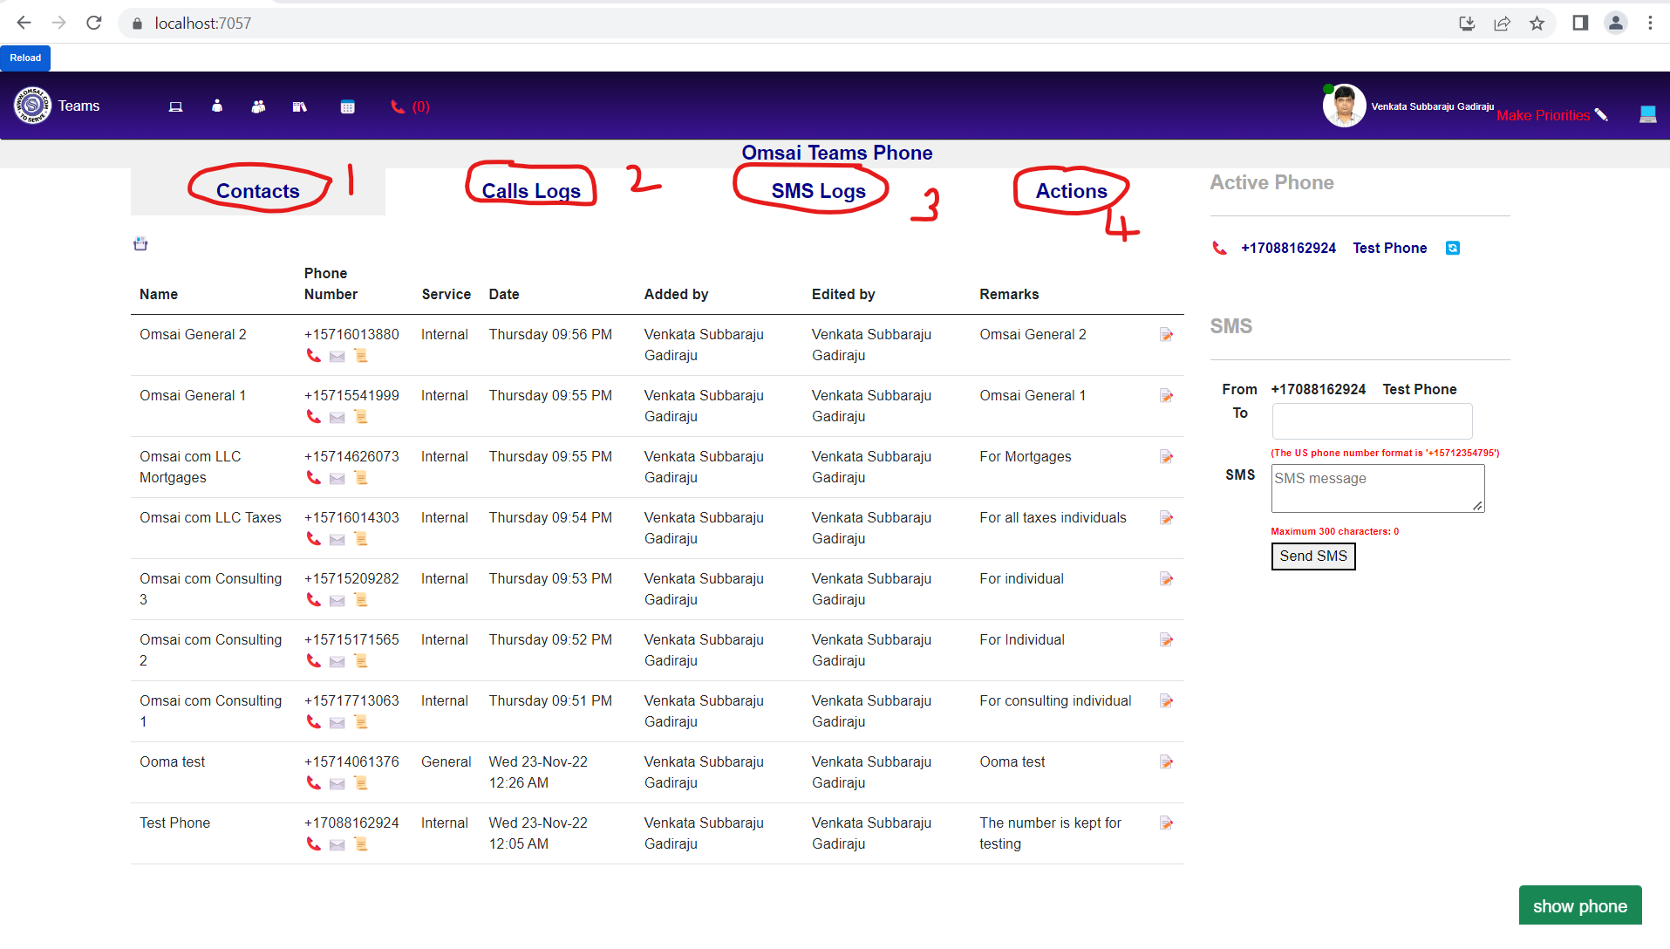

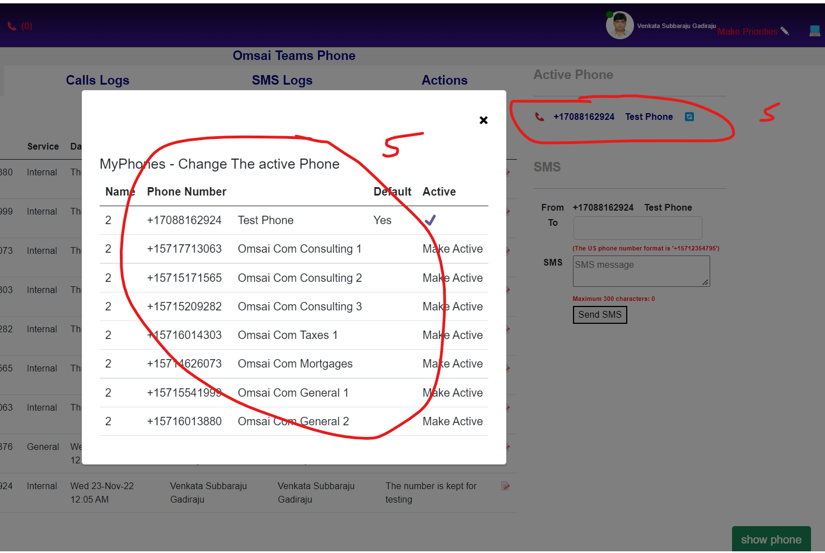

Point 1 in snap – Contacts Management (Add/edit)
Point 2 in snap – Call Logs. All missed calls to be addressed and closed.

Point 3 in snap – SMS Logs. All Received SMS to be addressed and closed.

Point 4 in snap -Actions. Example…Say Hari wants some body to follow up a client for a call received etc (Hari assigns the same in Actions)

Point 5 in snap – default phone shall be active, if allotted more than 1 number the end number can be made active. For example xxx is assigned with two number tax number say default) and mortgage number. Usually xxx major work is tax and if xxx wants to call to a mortgage client, he can switch over mortgage number and can call.

